Agenda for
January 7, 2020
Regular Meeting of Project Impact STEM Academy Board of Directors
6:30 PM 2275 W. Hubbard Rd. Kuna Idaho 4-6 House (Bldg. 3)

- CALL MEETING TO ORDER
  - Time ___________
- ROLL CALL (Jensen)

  - Director Fleming ____
  - Director Peterson ____
  - Director Martin ____
  - Director Jensen ____
  - vacant
Quorum Y/N

- READING OF MISSION or CHARTER DESIGN ELEMENTS (Jensen)
  - Mission: Project Impact STEM Academy will provide an engaging, adaptive learning environment through the use of personalized learning plans, intentionally integrated curriculum, mastery-based progression, and authentic projects embedded in science, technology, engineering, and math. In this environment, students will gain confidence, practice failure until it is no longer intimidating, and become invested in the life-long pursuit of knowledge.
  - Design Elements:
    - STEM will be developed as a school-wide culture through a focus on inquiry, problem solving, and flexible scheduling.
    - Curriculum will be mastery-based and personalized.
    - Curriculum will be integrated across subjects through use of project-based learning strategies as well as reading and writing projects.
    - Expanded assessment methodologies will be used school-wide, including portfolios, presentations, and rubrics that focus on critical thinking, communication, collaboration, and creativity.
- CONSENT AGENDA
  - Action Item: Adoption of the Agenda and Prior Meeting Minutes (20191203)
- ANNOUNCEMENTS/PUBLIC DISCUSSION
  - PPP Comments
  - Student Showcase
  - Public members wishing to speak on agenda item
- OFFICER REPORTS/INFORMATION
  - Chairman Report
  - Vice-Chairman Report
  - Treasurer Report
  - Secretary Report
  - Communications Report
    - Review Raffle
- COMMITTEE REPORTS/INFORMATION
  - Finance Committee
    - Action Item: Financial Reports Approval (November 2019)
  - Policy Committee
  - Advisory Committee
- ADMINISTRATION REPORT/INFORMATION
  - Recent and Upcoming Events
  - Staffing
    - Level Pay (classified year-round)
  - SDE/PCSC Reports
    - 2018-2019 PCSC Annual Performance Report
  - Facility/System Updates
  - Academic Programs
    - Action Item: Out of district SPED
    - Student/Employee Handbook
    - Action Item: SY 2020-2021 Class size
    - Action Item: SY 2020-2021Kindergarten
    - Action Item: Yearbook Club
  - CIP Review
    - Design Elements
    - Community Involvement
    - Literacy Intervention
    - College and Career Advising & Mentoring
- DISCUSSION/INFORMATION/ACTION
  - Board Vacancy update
  - Action Item: 2nd read/adopt Res 2019-06
- EXECUTIVE SESSION
  - Action Item: Under Idaho State Code 74-206 (b) To consider the evaluation, dismissal or disciplining of, or to hear complaints or charges brought against, a public officer, employee, staff member or individual agent, or public-school student.
- ACTION AGENDA/LIST
  - Action Item: Adoption of the Agenda and Prior Meeting Minutes
  - Action Item: Financial Reports Approval (November 2019)
  - Action Item: Out of district SPED
  - Action Item: SY 2020-2021 Class size
  - Action Item: 2nd read/adopt Res 2019-06
  - Action Item: Executive session, administrative evaluation
- ADJOURN
  - Time __________

* ADDITIONAL DETAILS
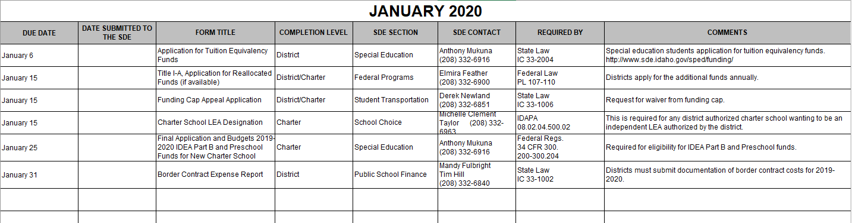

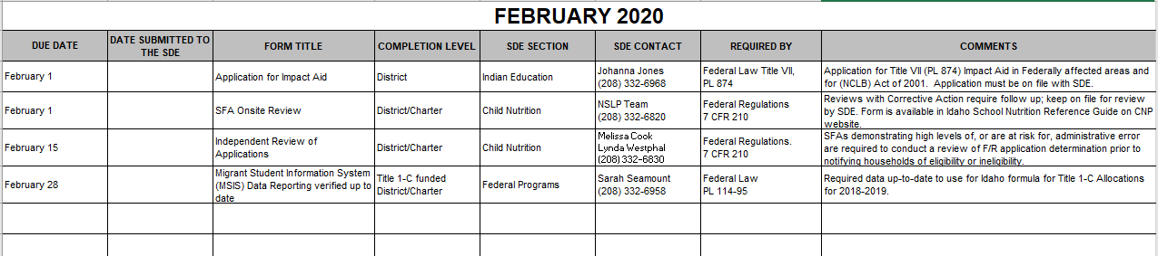
PROJECT IMPACT STEM ACADEMY
RESOLUTION 2019-06
AMENDING OF ATTENDANCE POLICY
NOW THEREFORE, be it ordained by the Board of Directors of Project Impact STEM Academy, in the State of Idaho, as follows:
SECTION 1: AMENDMENT “3050 Attendance Policy” of the Project Impact STEM Academy Policies & Procedures is hereby amended as follows:
A M E N D M E N T
3050 Attendance Policy
Students are expected to attend all assigned classes each day. Teachers shall keep a record of absence and tardiness. Before the end of the school day, each school shall attempt to contact every parent, guardian, or custodian whose child is absent from school but who has not reported the child as absent for the school day, to determine whether the parent, guardian, or custodian is aware of the child’s absence from school. The following are valid excuses for absence and tardiness. Missed work assignments and activities may be made up in the manner provided by the teacher.
- Participation in school-approved activity: To be excused, this absence must be authorized by a staff member and the affected teacher(s) must be notified prior to the absence unless it is clearly impossible to do so.
- Absence caused by illness, health condition, or family emergency: When possible, the parent is expected to notify the school office on the morning of the absence and send a signed note of explanation with the student upon his or her return to school. A student shall be allowed one makeup day for each day of absence. “Emergency” shall be defined as unforeseen and unexpected circumstances which create an air of crisis or extreme need. Such circumstances must present a grave and clear danger which could result in irremediable harm or immediate disaster.
- Absence for parental-approved activities: This category of absence shall be counted as excused for purposes agreed upon by the Executive Director Director of Education and the parent. An absence may not be approved if it causes a serious adverse effect on the student’s educational progress. In participation-type classes, such as many within the charter's project-based model certain music and physical education classes, the student may not be able to achieve the objectives of the unit of instruction as a result of absence from class. In such a case, a parent-approved absence would have an adverse effect on the student’s educational progress, which would ultimately be reflected in the grade for such a course.
- Absence resulting from disciplinary actions or short-term suspension: Students who are removed from a class or classes as a disciplinary measure, or students who have been placed on short-term suspension, shall have the right to make up assignments or exams missed during time they were denied entry to the classroom.
Extended Illness or Health Condition If a student is confined to home or hospital for an extended period, the school shall arrange for the accomplishment of assignments at the place of confinement whenever practicable. If the student is unable to do his or her schoolwork, or if there are major requirements of a particular course that cannot be accomplished outside of class, the student may be required to take an incomplete or withdraw from the class without penalty. Excused Absence for Chronic Health Condition Students with a chronic health condition which interrupts regular attendance may qualify for placement in a limited attendance and participation program. The student and his or her parent shall apply to the Executive Director Director of Education or designee counselor, and a limited program shall be written following the advice and recommendations of the student’s medical advisor. The recommended limited program shall be approved by the Executive Director Director of Education. Staff shall be informed of the student’s needs, though the confidentiality of medical information shall be respected at the parent’s request. Absence verified by a medical practitioner may be sufficient justification for home instruction.
Unexcused Absences A student's absences can adversely affect their educational continuity. Additionally, in the charter's classroom and educational model, continued absences can damage the culture and classwork for the larger group.
- Each unexcused absence shall be followed by a warning letter to the parent of the student. A student’s grade shall not be affected if no graded activity is missed during such an absence.
- When a student evidences repeated truancies, defined as an average daily attendance (ADA) less than 90% for a given reporting period, a conference shall be held among the parent, student, and Executive Director Director of Education. At such a conference, the Executive Director Director of Education, student, and parent shall consider adjusting the student’s program or transferring the student to another school or engaging in family counseling.
- If the above action fails to correct the truancy problem, the student shall be declared a habitual truant. An The attendance administrator shall interview the student and his or her family and prescribe corrective action, which may include loss of seat, expulsion, and/or filing a complaint against the parent/guardian, or other person responsible for the care of the child in a court of competent jurisdiction. A student who has been expelled for attendance violations may petition the Board of Directors for reinstatement. Such petition may be granted upon presentation of a firm and unequivocal commitment to maintain regular attendance.
Students are expected to be in class on time. When a student’s tardiness becomes frequent or disruptive, the student shall be referred to the Executive Director, Dean of Students, Director of Education or counselor. If counseling, parent conference, or disciplinary action is ineffective in changing the student’s attendance behavior, he or she may be suspended from the class. All sanctions imposed for failure to comply with the attendance policies and procedures shall be implemented in conformance with State and Charter School regulations regarding corrective action or punishment.

