Agenda for
October 1, 2019
Regular Meeting of Project Impact STEM Academy Board of Directors
6:30 PM 2275 W. Hubbard Rd. Kuna Idaho 4-6 House (Bldg. 3)

- CALL MEETING TO ORDER
  - Time ___________
- ROLL CALL (Peterson)

  - Director Fleming ____
  - Director Peterson ____
  - Director Martin ____
  - Director Jensen ____
  - vacant
Quorum Y/N

- MISSION and/or CHARTER DESIGN ELEMENTS (Peterson)
  - Mission: Project Impact STEM Academy will provide an engaging, adaptive learning environment through the use of personalized learning plans, intentionally integrated curriculum, mastery-based progression, and authentic projects embedded in science, technology, engineering, and math. In this environment, students will gain confidence, practice failure until it is no longer intimidating, and become invested in the life-long pursuit of knowledge.
  - Design Elements:
    - STEM will be developed as a school-wide culture through a focus on inquiry, problem solving, and flexible scheduling.
    - Curriculum will be mastery-based and personalized.
    - Curriculum will be integrated across subjects through use of project-based learning strategies as well as reading and writing projects.
    - Expanded assessment methodologies will be used school-wide, including portfolios, presentations, and rubrics that focus on critical thinking, communication, collaboration, and creativity.
- CONSENT AGENDA
  - Action Item: Adoption of the Agenda and Prior Meeting Minutes (20190903, 20190919)
- ANNOUNCEMENTS/PUBLIC DISCUSSION
  - PPP Comments
  - Student Showcase
  - Public members wishing to speak
- OFFICER REPORTS/INFORMATION
  - Chairman Report
    - ISBA training date (post-convention)
    - Convention Coverage (Nov 5th)
  - Vice-Chairman Report
  - Treasurer Report
  - Secretary Report
    - Action Item: Define/assign Municode users
  - Communications Report
- COMMITTEE REPORTS/INFORMATION
  - Finance Committee
    - Action Item: Financial Reports Approval (August 2019)
  - Policy Committee
    - No update.
  - Administrative Evaluation Committee
    - Action Item: 2019-2020 CIP approval*
    - Membership adjustment
  - Advisory Committee
    - No update
- ADMINISTRATION REPORT/INFORMATION
  - Recent and Upcoming Events
  - Staffing Updates
    - Year-round para request
  - SDE/PCSC Reports
    - Safety Inspection
    - Busing Audit
    - Data Acquisition Calendar*
  - Facility/System Updates
    - Action Item: Temp (awaiting policies) facility use request
    - Action Item: 2nd read/adopt Policy 8120 (possibly not in Municode notice)
  - Academic Programs
    - Action Item: Out of district SPED
- DISCUSSION/INFORMATION/ACTION
  - Board Vacancy update
  - Handbook updates
  - Action Item: Additional Municode Book (agenda/minutes/finance)
  - Action Item: PPP/PTA Management of Logo use 2019-2020
  - Action Item: Policy revisions*
- EXECUTIVE SESSION
  - Action Item: Enter Executive Session - Under Idaho State Code 74-206 (c) To acquire an interest in real property not owned by a public agency. Possible action items to occur following session.
- ACTION AGENDA/LIST
  - Action Item: Adoption of the Agenda and Prior Meeting Minutes
  - Action Item: Define/assign Municode users
  - Action Item: Financial Reports Approval (August 2019)
  - Action Item: 2019-2020 CIP approval*
  - Action Item: Temp Facility Use agreement
  - Action Item: 2nd read/adopt Policy 8120
  - Action Item: Out of district SPED
  - Action Item: Additional Municode Book (agenda/minutes/finance)
  - Action Item: PPP/PTA Management of Logo use 2019-2020
  - Action Item: 1st Read of Policy revisions*
  - Action Item: Enter Executive Session
  - Action Item: Possible post Executive Session items
- ADJOURN
  - Time __________

* ADDITIONAL DETAILS
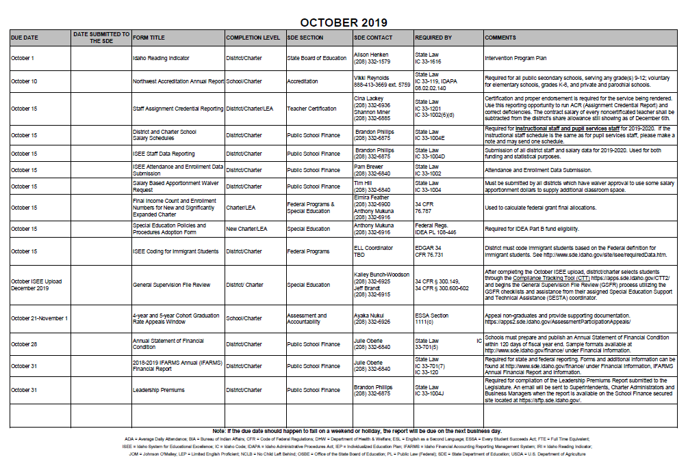
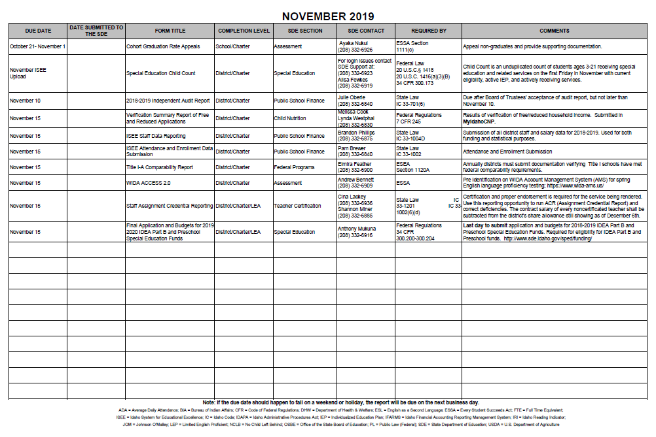

20191001 Policy Revision requests:

Policy Preface
1st read of edits to policy 1315
Addition of 1315CIP – Continuous Improvement Plan
1st read of edits to policy 4210
1st read of edits to policy 4210F
1st read of edits to policy 4210P
1st read of edits to policy 4220
1st read of edits to policy 8110
2nd read/adoption of edits to policy 8120

