Agenda for
November 05, 2019
Regular Meeting of Project Impact STEM Academy Board of Directors
6:30 PM 2275 W. Hubbard Rd. Kuna Idaho 4-6 House (Bldg. 3)

- CALL MEETING TO ORDER
  - Time ___________
- ROLL CALL (Jensen)

  - Director Fleming ____
  - Director Peterson ____
  - Director Martin ____
  - Director Jensen ____
  - vacant
Quorum Y/N

- MISSION and/or CHARTER DESIGN ELEMENTS (Jensen)
  - Mission: Project Impact STEM Academy will provide an engaging, adaptive learning environment through the use of personalized learning plans, intentionally integrated curriculum, mastery-based progression, and authentic projects embedded in science, technology, engineering, and math. In this environment, students will gain confidence, practice failure until it is no longer intimidating, and become invested in the life-long pursuit of knowledge.
  - Design Elements:
    - STEM will be developed as a school-wide culture through a focus on inquiry, problem solving, and flexible scheduling.
    - Curriculum will be mastery-based and personalized.
    - Curriculum will be integrated across subjects through use of project-based learning strategies as well as reading and writing projects.
    - Expanded assessment methodologies will be used school-wide, including portfolios, presentations, and rubrics that focus on critical thinking, communication, collaboration, and creativity.
- CONSENT AGENDA
  - Action Item: Adoption of the Agenda and Prior Meeting Minutes (20191001, 20191022)
- ANNOUNCEMENTS/PUBLIC DISCUSSION
  - PPP Comments
  - Student Showcase
  - Public members wishing to speak
- OFFICER REPORTS/INFORMATION
  - Chairman Report
    - IMEN convention notes
  - Vice-Chairman Report
  - Treasurer Report
    - Action Item: 2018-2019 Financial Audit
  - Secretary Report
    - Open Meeting Law/Public Record Requests
  - Communications Report
- COMMITTEE REPORTS/INFORMATION
  - Finance Committee
    - Action Item: Financial Reports Approval (September 2019)
  - Policy Committee
    - Begin review of notes from recent SDE busing audit.
  - Administrative Evaluation Committee
    - No update.
  - Advisory Committee
    - No update
- ADMINISTRATION REPORT/INFORMATION
  - Recent and Upcoming Events
  - Staffing Updates
    - Update/additional info: Year-round para request
  - SDE/PCSC Reports
    - Data Acquisition Calendar*
  - Facility/System Updates
  - Academic Programs
    - Action Item: Out of district SPED
    - Student/Employee Handbook
- DISCUSSION/INFORMATION/ACTION
  - Board Vacancy update
  - Action Item: Res 19-04 Metric detail update to CIP
  - Action Item: Res 19-02 Policy revisions*
- ACTION AGENDA/LIST
  - Action Item: Adoption of the Agenda and Prior Meeting Minutes
  - Action Item: Acceptance 2018-2019 Financial Audit
  - Action Item: Financial Reports Approval (September 2019)
  - Action Item: 2nd read/adopt Policy 1315
  - Action Item: 2nd read/adopt Policy 4210
  - Action Item: 2nd read/adopt Policy 4210F
  - Action Item: 2nd read/adopt Policy 4210P
  - Action Item: 2nd read/adopt Policy 4220
  - Action Item: 2nd read/adopt Policy 8110
  - Action Item: Out of district SPED
- ADJOURN
  - Time __________

* ADDITIONAL DETAILS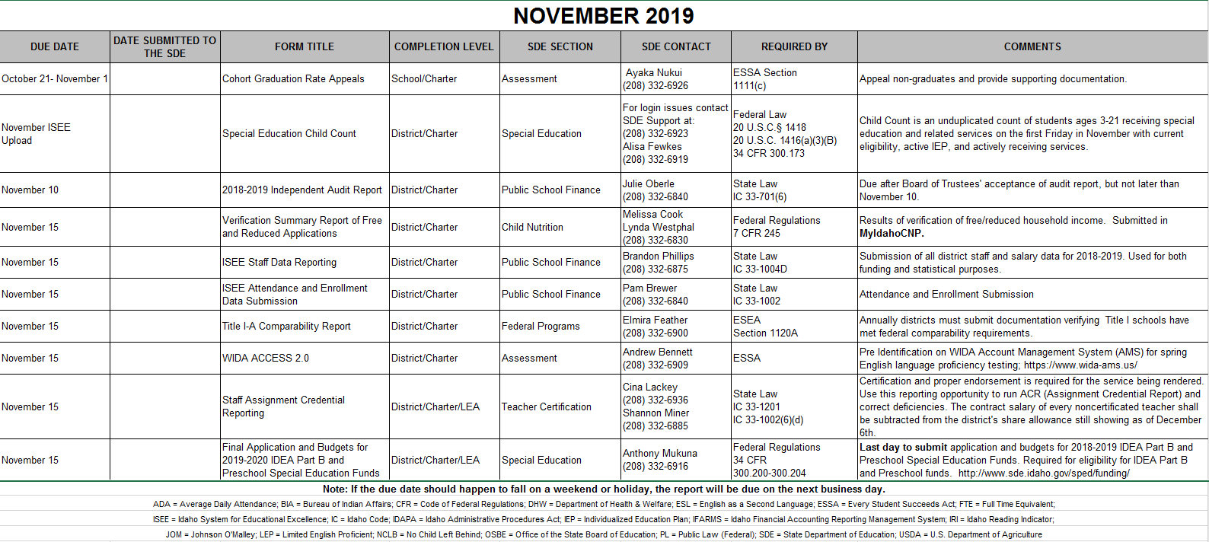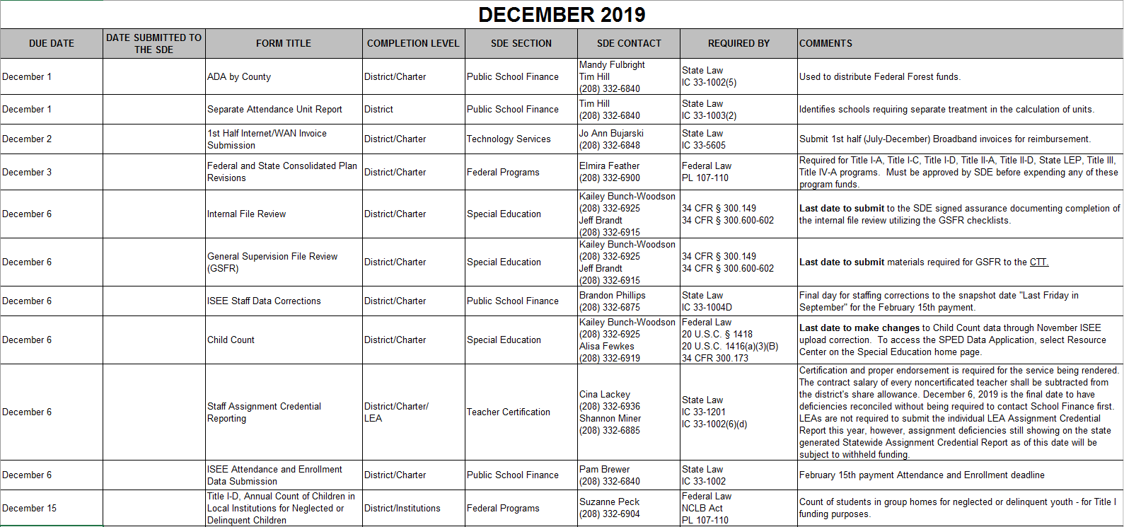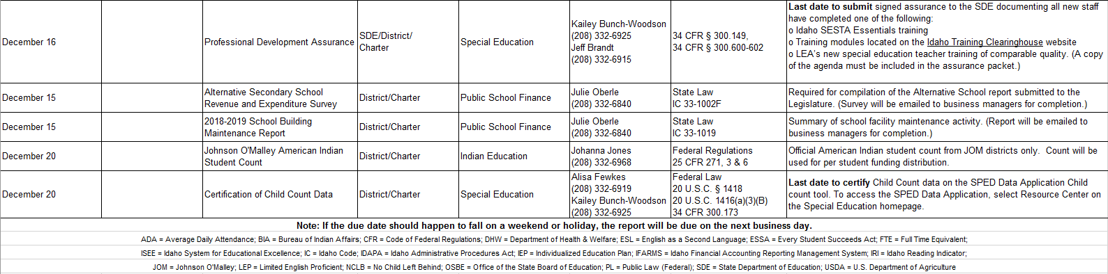

Resolution 19-02 Policy Revisions:

2nd read/adoption of edits to policy 1315
2nd read/adoption of edits to policy 4210
2nd read/adoption of edits to policy 4210F
2nd read/adoption of edits to policy 4210P
2nd read/adoption of edits to policy 4220
2nd read/adoption of edits to policy 8110

