Agenda for
December 3, 2019
Regular Meeting of Project Impact STEM Academy Board of Directors
6:30 PM 2275 W. Hubbard Rd. Kuna Idaho 4-6 House (Bldg. 3)

- CALL MEETING TO ORDER
  - Time ___________
- ROLL CALL (Martin)

  - Director Fleming ____
  - Director Peterson ____
  - Director Martin ____
  - Director Jensen ____
  - vacant
Quorum Y/N

- READING OF MISSION or CHARTER DESIGN ELEMENTS (Martin)
  - Mission: Project Impact STEM Academy will provide an engaging, adaptive learning environment through the use of personalized learning plans, intentionally integrated curriculum, mastery-based progression, and authentic projects embedded in science, technology, engineering, and math. In this environment, students will gain confidence, practice failure until it is no longer intimidating, and become invested in the life-long pursuit of knowledge.
  - Design Elements:
    - STEM will be developed as a school-wide culture through a focus on inquiry, problem solving, and flexible scheduling.
    - Curriculum will be mastery-based and personalized.
    - Curriculum will be integrated across subjects through use of project-based learning strategies as well as reading and writing projects.
    - Expanded assessment methodologies will be used school-wide, including portfolios, presentations, and rubrics that focus on critical thinking, communication, collaboration, and creativity.
- CONSENT AGENDA
  - Action Item: Adoption of the Agenda and Prior Meeting Minutes (20191105, 20191121)
- ANNOUNCEMENTS/PUBLIC DISCUSSION
  - PPP Comments
  - Student Showcase
  - Public members wishing to speak on agenda item
- OFFICER REPORTS/INFORMATION
  - Chairman Report
    - 2019 ISBA Convention
  - Vice-Chairman Report
  - Treasurer Report
    - Action Item: 2019-2020 mid-year budget revision
  - Secretary Report
  - Communications Report
- COMMITTEE REPORTS/INFORMATION
  - Finance Committee
    - Action Item: Financial Reports Approval (October 2019)
    - ADA reporting/general funding overview
  - Policy Committee
  - Administrative Evaluation Committee
    - Action Item: Absorb committee function into regular board meetings
  - Advisory Committee
- ADMINISTRATION REPORT/INFORMATION
  - Recent and Upcoming Events
    - MOSS trip
    - Rock band (The Fleurs) 12/10 concert
    - Giving Tuesday
    - Informational Night
  - Staffing Updates
  - SDE/PCSC Reports
    - Data Acquisition Calendar*
  - Facility/System Updates
  - Academic Programs
    - Action Item: Out of district SPED
    - Student/Employee Handbook
    - Action Item: Set Lottery Schedule
  - Goal Progress
    - Design Elements
    - Community Involvement
    - Literacy Intervention
    - College and Career Advising & Mentoring
- DISCUSSION/INFORMATION/ACTION
  - Performance Framework Review & Survey
  - Board Vacancy update
  - Action Item: 1st read Policy 3050 (Res 2019-06)
- ACTION AGENDA/LIST
  - Action Item: Adoption of the Agenda and Prior Meeting Minutes
  - Action Item: 2019-2020 mid-year budget revision
  - Action Item: Financial Reports Approval (October 2019)
  - Action Item: Dissolution of Eval Committee
  - Action Item: Out of district SPED
  - Action Item: Set lottery schedule
  - Action Item: 1st read Policy 3050 (Res 2019-06)
- ADJOURN
  - Time __________

* ADDITIONAL DETAILS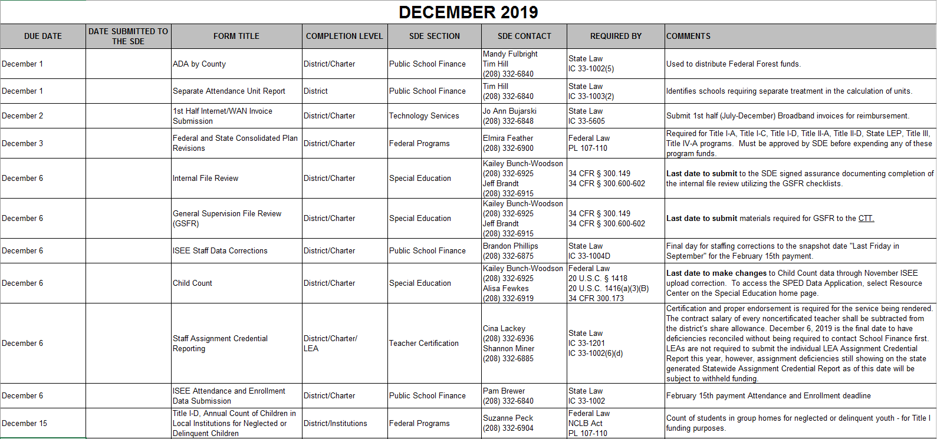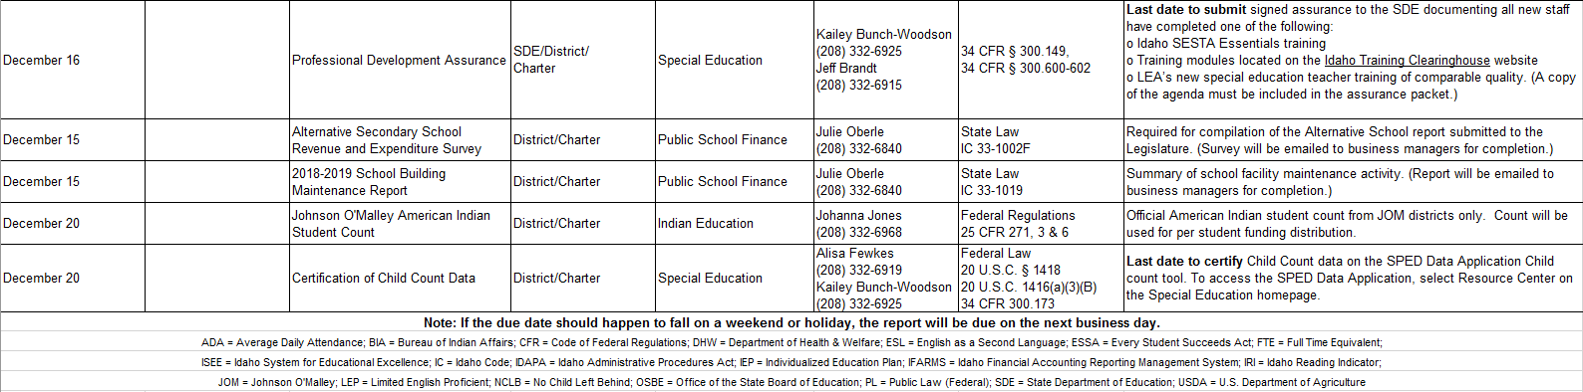
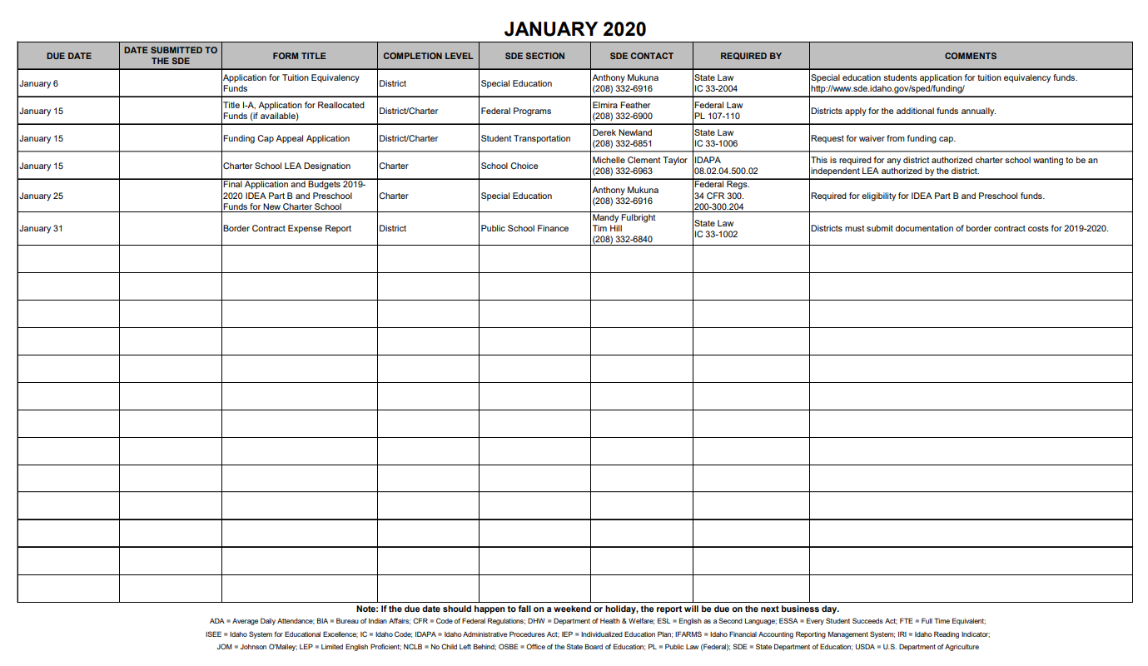
Performance Framework:
Conditions of Authorization / Renewal
1. PiSA will achieve accreditation candidacy status by July 1, 2019, and full accreditation
through the Northwest Accreditation Commission by July 1, 2021.
2. By July 1, 2022, PiSA will obtain STEM certification, either as a program or as a school, at
the sustaining level. Such certification shall be maintained at the sustaining level throughout the
remainder of the performance certificate term.
3. By January 31, 2018, PiSA will submit to the PCSC office a signed, written commitment from
Giza Development that PiSA is not committed to permanent facility construction on any specific
timeline.

