Agenda for June 1, 2021
Annual Meeting of Project Impact STEM Academy Board of Directors
Zoom Meeting Meeting ID: 767 3806 8758 Passcode: 7rg0c4

- CALL MEETING TO ORDER
  - Time ___________
- ROLL CALL (White)

  - Director Fleming ____
  - Director Peterson ____
  - Director Jensen ____
  - Director White ____
Quorum Y/N

- READING OF MISSION (White)
  - Mission: Project Impact STEM Academy will provide an engaging, adaptive learning environment through the use of personalized learning plans, intentionally integrated curriculum, mastery-based progression, and authentic projects embedded in science, technology, engineering, and math. In this environment, students will gain confidence, practice failure until it is no longer intimidating, and become invested in the life-long pursuit of knowledge.
- CONSENT AGENDA
  - Action Item: Adoption of the Agenda and Prior Meeting Minutes (20210504, 20210513)
- ANNOUNCEMENTS/PUBLIC DISCUSSION
  - Public members wishing to speak
- OFFICER REPORTS/INFORMATION
  - Chairman Report
  - Vice-Chairman Report
    - Member Renewal oaths: Director Fleming, Director Peterson
    - Action Item: New Board members application(s)
  - Treasurer Report
  - Secretary Report
    - Action Item: Officer Positions for 2021-2022 SY (Chairman, Vice-Chair, Secretary)
    - Board Communications (if any)
- COMMITTEE REPORTS/INFORMATION
  - (Admin) Finance Committee
    - Action Item: Financial Reports Approval (April 2021)
    - Action Item: Acceptance of ESSR II (additional funding) plan
    - Action Item: 21-22 PowerSchool Contract
    - Action Item: 21-22 Employee Health Benefit Plan
    - Action Item: 21-22 Employee Vision/Life Insurance Plan
    - Action Item: 21-22 West Valley Tech IT Services Contract
    - Action Item: (COVID funded) Employee Assistance Program (EAP)
    - Action Item: 21-22 Meraki licenses
- DISCUSSION/INFORMATION/ACTION
  - Budget Hearing: Board of Trustees of the Project Impact STEM Academy Charter School #513 NOTICE IS HEREBY GIVEN, that a Special board of trustees meeting of the Project Impact STEM Academy Charter School #513, Ada County, Idaho will be held on the 1st day of June 2021, to include an online version at the Zoom meeting linked above, at which meeting there shall be a public hearing on a maintenance and operation budget for the 2021-2022 school year and amended budget for the 2020-2021 school year. The following presented tentative budgets are available for public inspection, a copy is available upon request, and will remain available until the meeting and hearing, as provided by law. This meeting and budget hearing is called pursuant to Idaho Code 33-801.
    - Action Item: Adopt amended 2020-2021 Budget
    - Action Item: Adopt 2021-2022 Budget
  - Action Item: 2nd Read/ Adoption of Res 2021-03
- CONTINUED REPORTS/INFORMATION
  - National School Lunch Program (Ms. Brashears)
- ADMINISTRATION REPORTS/INFORMATION/ACTION
  - BUSINESS MANAGER
    - Business Manager Evaluation Schedule
      - Action Item: Set schedule for 2021-2022 SY
  - EXECUTIVE DIRECTOR
    - Administration Evaluation Schedule
      - Action Item: Set schedule for 2021-2022 SY
    - Revised 2021-2022 SY Calendar (senior schedule/graduation dates)
      - Action Item: 2021-2022 SY Calendar (revised)
    - Revised PDs for Dean of Students, Tech Coordinator
      - Action Item: Approval of revised PDs
    - 2021 Legislative Roadshow Update
    - SY22 Student/Patron Updates (Enrollment, Programs, Engagement Activities)
    - SY22 Staffing Updates (Positions, Training)
    - SY22 Facility Updates (Improvements, Issues)
- EXECUTIVE SESSION
  - Action Item: Under Idaho State Code 74-206 (a) To consider hiring a public officer, employee, staff member or individual agent, wherein the respective qualities of individuals are to be evaluated in order to fill a particular vacancy or need. This paragraph does not apply to filling a vacancy in an elective office or deliberations about staffing needs in general;
  - Action Item: 2021-2022 Staffing Contracts/Hires
- ACTION AGENDA
  - Action Item: Adoption of the Agenda and Prior Meeting Minutes
  - Action Item: New Board members application(s)
  - Action Item: Officer Positions for 2021-2022 SY
  - Action Item: Financial Reports Approval (April 2021)
  - Action Item: Acceptance of ESSR II (additional funding) plan
  - Action Item: 21-22 PowerSchool Contract
  - Action Item: 21-22 Employee Health Benefit Plan
  - Action Item: 21-22 Employee Vision/Life Insurance Plan
  - Action Item: 21-22 West Valley Tech IT Services Contract
  - Action Item: (COVID funded) Employee Assistance Program (EAP)
  - Action Item: 21-22 Meraki licenses
  - Action Item: Adopt revised 2020-2021 Budget
  - Action Item: Adopt 2021-2022 Budget
  - Action Item: 2nd Read/ Adoption of Res 2021-03
  - Action Item: Set Business Manager Eval schedule for 2021-2022 SY
  - Action Item: Set Executive Director Eval schedule for 2021-2022 SY
  - Action Item: 2021-2022 SY Calendar (revised)
  - Action Item: Approval of Revised PDs
  - Action Item: Enter Executive Session F: __ P: __ J: __ W: __ Time: ______
  - Action Item: Exit Executive Session Time: ______
  - Action Item: 2021-2022 Staffing Contracts/Hires
- ADJOURN
  - Time __________

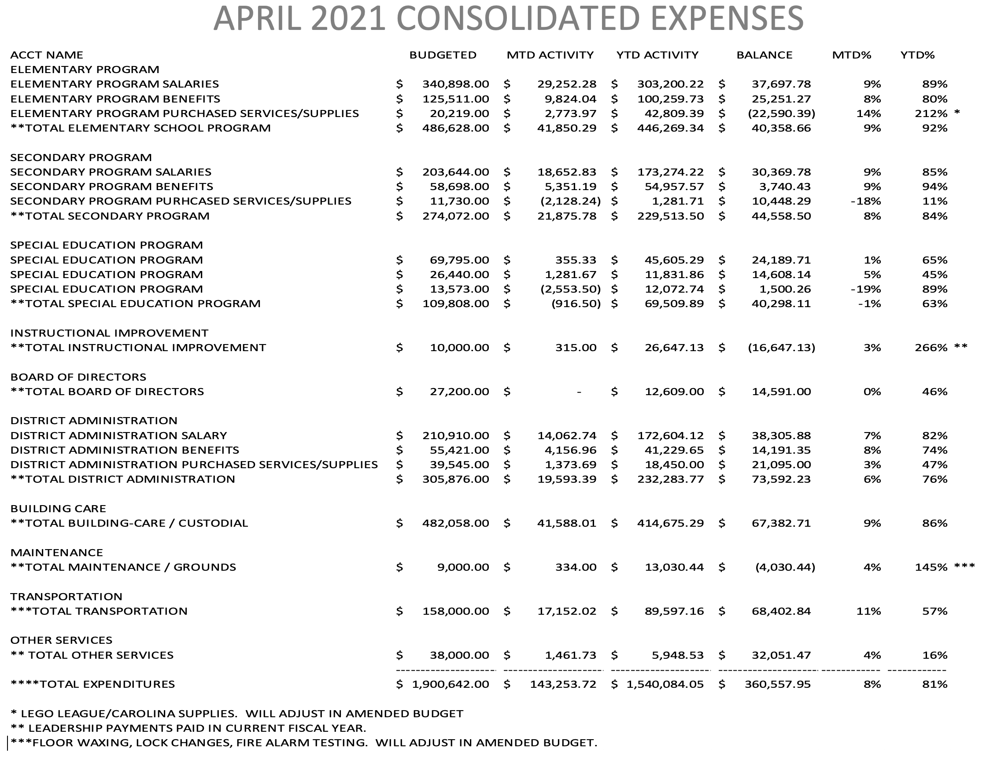

2020-2021 Amended Budget & 2021-2022 Budget Proposals:

Pi STEM ACADEMY
ALL FUNDS | Current Budget | Amended Budget | Proposed Budget
REVENUES/EXPENDITURES | 2020-2021 | 2020-2021 | 2021-2022
Beginning Balances | $ - | $ (278,549.00) | $ (250,000.00)
Local Revenue | $ (118,000.00) | $ (31,504.00) | $ (101,960.00)
County Revenue | $ - | $ - | $ -
State Revenue | $ (1,782,642.00) | $ (1,553,753.00) | $ (1,874,153.00)
Federal Revenue | $ (321,671.00) | $ (597,304.00) | $ (151,472.00)
Other Sources | $ - | $ - | $ -
Transfers | $ (62,797.00) | $ - | $ -
TOTALS *** | $ (2,285,110.00) | $ (2,461,110.00) | $ (2,377,585.00)
Salaries | $ 976,576.00 | $ 959,736.00 | $ 1,098,368.00
Benefits | $ 266,070.00 | $ 255,381.00 | $ 319,891.00
Purchased Services | $ 748,634.00 | $ 860,749.00 | $ 841,982.00
Supplies & Materials | $ 71,499.00 | $ 95,727.00 | $ 85,319.00
Capital Outlay | $ 48,745.00 | $ 159,565.00 | $ 1,100.00
Debt Retirement | $ 62,816.00 | $ 2,205.00 | $ 15,625.00
Insurance & Judgments | $ 15,035.00 | $ 14,797.00 | $ 15,300.00
Transfers | $ 61,590.00 | $ - | $ -
Contingency Reserve | $ 15,000.00 | $ 112,950.00 | $ -
Unappropriated Balances | $ 19,145.00 | $ - | -
TOTALS *** | $ 2,285,110.00 | $ 2,461,110.00 | $ 2,377,585.00

