Meeting Minuntes for
December 3, 2019
Regular Meeting of Project Impact STEM Academy Board of Directors
6:30 PM 2275 W. Hubbard Rd. Kuna Idaho 4-6 House (Bldg. 3)

- CALL MEETING TO ORDER
  - Time _6:28 PM_
- ROLL CALL (Martin)

  - Director Fleming _Y_
  - Director Peterson _Y_
  - Director Martin __Y__
  - Director Jensen __Y__
  - vacant
Quorum Y

- READING OF MISSION or CHARTER DESIGN ELEMENTS (Martin)
  - Mission: Project Impact STEM Academy will provide an engaging, adaptive learning environment through the use of personalized learning plans, intentionally integrated curriculum, mastery-based progression, and authentic projects embedded in science, technology, engineering, and math. In this environment, students will gain confidence, practice failure until it is no longer intimidating, and become invested in the life-long pursuit of knowledge.
  - Design Elements:
    - STEM will be developed as a school-wide culture through a focus on inquiry, problem solving, and flexible scheduling.
    - Curriculum will be mastery-based and personalized.
    - Curriculum will be integrated across subjects through use of project-based learning strategies as well as reading and writing projects.
    - Expanded assessment methodologies will be used school-wide, including portfolios, presentations, and rubrics that focus on critical thinking, communication, collaboration, and creativity.
- CONSENT AGENDA
  - Action Item: Adoption of the Agenda and Prior Meeting Minutes (20191105, 20191121)
- ANNOUNCEMENTS/PUBLIC DISCUSSION
  - PPP Comments
  - Student Showcase
  - Public members wishing to speak on agenda item
- OFFICER REPORTS/INFORMATION
  - Chairman Report
    - 2019 ISBA Convention
  - Vice-Chairman Report
  - Treasurer Report
    - Action Item: 2019-2020 mid-year budget revision
  - Secretary Report
  - Communications Report
- COMMITTEE REPORTS/INFORMATION
  - Finance Committee
    - Action Item: Financial Reports Approval (October 2019)
    - ADA reporting/general funding overview
  - Policy Committee
  - Administrative Evaluation Committee
    - Action Item: Absorb committee function into regular board meetings
  - Advisory Committee
- ADMINISTRATION REPORT/INFORMATION
  - Recent and Upcoming Events
    - MOSS trip
    - Rock band (The Fleurs) 12/10 concert
    - Giving Tuesday
    - Informational Night
  - Staffing Updates
  - SDE/PCSC Reports
    - Data Acquisition Calendar*
  - Facility/System Updates
  - Academic Programs
    - Action Item: Out of district SPED
    - Student/Employee Handbook
    - Action Item: Set Lottery Schedule
  - Goal Progress
    - Design Elements
    - Community Involvement
    - Literacy Intervention
    - College and Career Advising & Mentoring
- DISCUSSION/INFORMATION/ACTION
  - Performance Framework Review & Survey
  - Board Vacancy update
  - Action Item: 1st read Policy 3050 (Res 2019-06)
- ACTION AGENDA/LIST
  - Action Item: Adoption of the Agenda and Prior Meeting Minutes Motion to approve Consent Agenda M/S Peterson/Jensen - passed
  - Action Item: 2019-2020 mid-year budget revision Motion to accept 2019-2020 mid-year budget revision M/S Martin/Peterson - passed
  - Action Item: Financial Reports Approval (October 2019) Motion to Accept Financial Reconciled Report M/S Jensen/Peterson - passed
  - Action Item: Dissolution of Eval Committee Motion to absorb the Administrative Evaluation Committee functions into regular board meetings with addendum to have the mid-year evaluation during an executive session at the regular January board meeting and to change the “Goal Process” section of the agenda to “Continuous Improvement Plan Review” M/S Martin/Jensen - passed
  - Action Item: Out of district SPED Motion to move to the regular January board meeting M/S Martin/Jensen - passed
  - Action Item: Set lottery schedule
Motion to set the lottery schedule to:
January 1, 2020 Open lottery applications
April 1, 2020 Close lottery applications
April 6, 2020 at 44:00 pm Pull the lottery
M/S Martin/Peterson - passed
  - Action Item: 1st read Policy 3050 (Res 2019-06) Motion to approve 1st read of policy 3050 with noted revisions M/S Martin/Peterson - passed
- ADJOURN
  - Time ___9:02 PM______ Motion to adjourn meeting M/S Peterson/Martin - passed

* ADDITIONAL DETAILS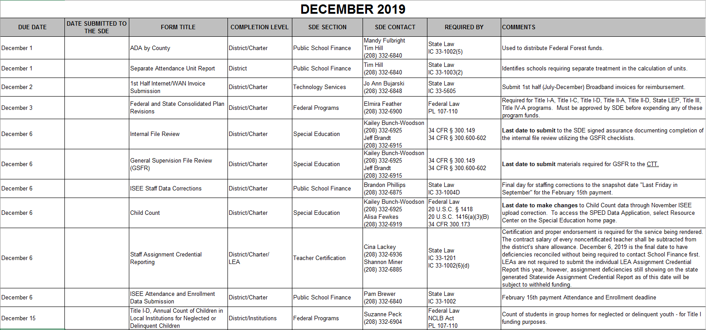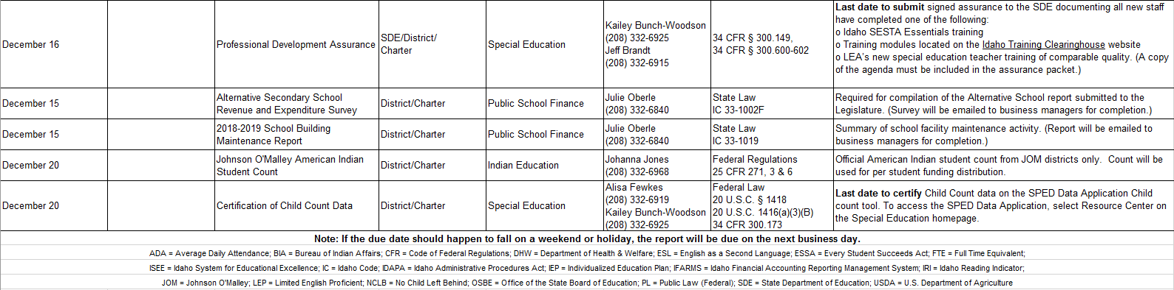
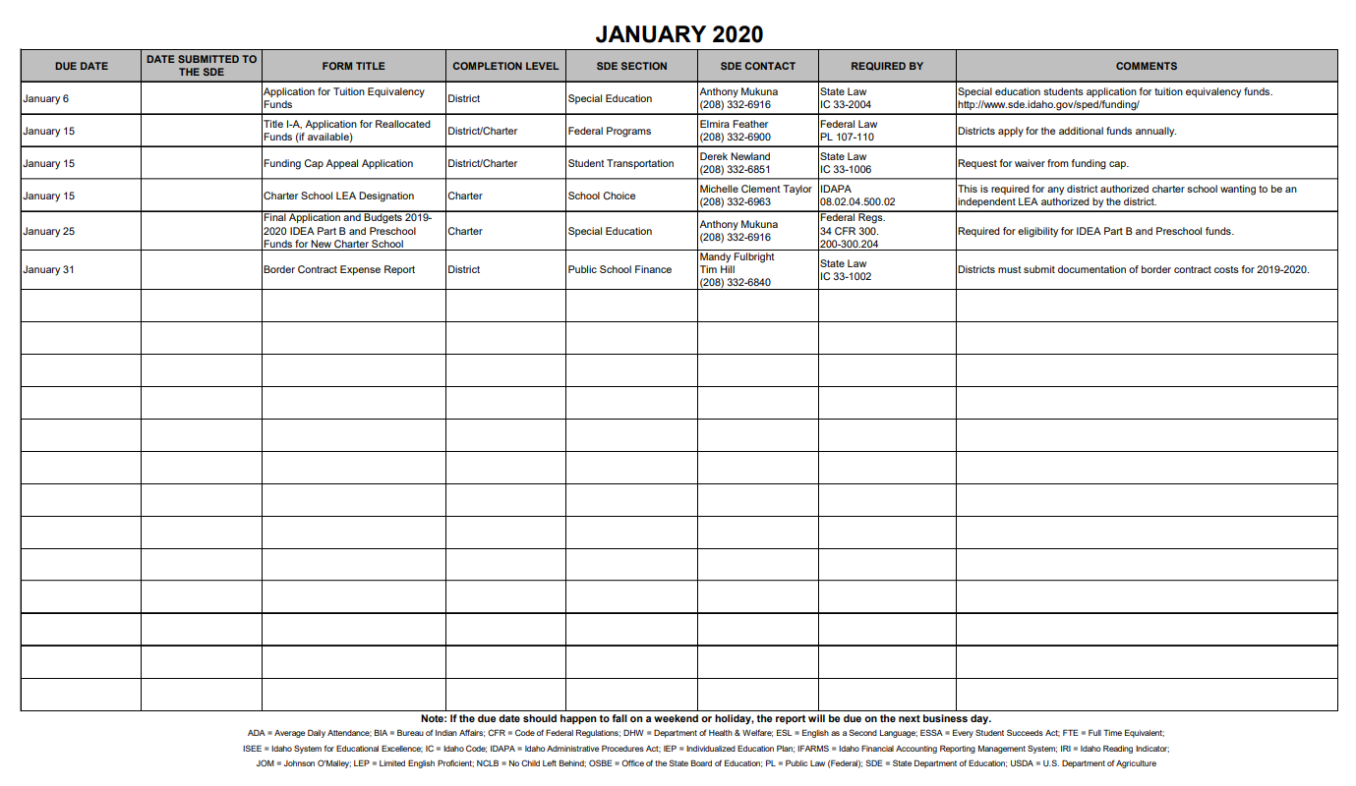
Performance Framework:
Conditions of Authorization / Renewal
1. PiSA will achieve accreditation candidacy status by July 1, 2019, and full accreditation
through the Northwest Accreditation Commission by July 1, 2021.
2. By July 1, 2022, PiSA will obtain STEM certification, either as a program or as a school, at
the sustaining level. Such certification shall be maintained at the sustaining level throughout the
remainder of the performance certificate term.
3. By January 31, 2018, PiSA will submit to the PCSC office a signed, written commitment from
Giza Development that PiSA is not committed to permanent facility construction on any specific
timeline.

