- CALL MEETING TO ORDER
  - Time _6:30PM__
- ROLL CALL (Peterson)
  - Director Fleming __y__ d. Director White _n__
  - Director Peterson __y__ e. Director Hopping _y__
  - Director Jensen __y__ Quorum Y
- READING OF MISSION or CHARTER DESIGN ELEMENTS (Peterson)
  - Mission: Project Impact STEM Academy will provide an engaging, adaptive learning environment through the use of personalized learning plans, intentionally integrated curriculum, mastery-based progression, and authentic projects embedded in science, technology, engineering, and math. In this environment, students will gain confidence, practice failure until it is no longer intimidating, and become invested in the life-long pursuit of knowledge.
- CONSENT AGENDA
  - Action Item: Adoption of the Agenda and Prior Meeting Minutes (20220503, 20220506, 20220510, 20220512, and 20220526)
    - M: Peterson Consent Agenda S: Hopping – 4 aye/ 1 absent - passed
- ANNOUNCEMENTS/PUBLIC DISCUSSION
  - Outreach Update – no updates
  - PTA Update – no updates
  - Public Comment – no comments
- OFFICER REPORTS/INFORMATION/ACTION
  - Chairman Report
    - Board Seat renewals – thank you for your continued support!
      - Director Jensen – 2022-2024
      - Director White – 2022-2024
      - Director Hopping – 2022-2024
    - PCSC Commission Meeting 6/9 at 9:00AM JR Williams Building, West Conference Room; 700 W. State Street; Boise, ID 83702
    - Action Item: SY23 Regular Board Meeting Calendar
      - M: Peterson Approve SY23 Board Calendar S: Hopping – 4 aye/ 1 absent - passed
    - Process Improvements
      - Meetings: Requested Items – 11 days prior (Friday)
      - Meetings: Draft Agenda Presented – 10 days prior (Saturday)
      - Meetings: Agenda/Materials – 7 days prior (Tuesday)
      - Membership: Review/Revise Onboarding – Director Hopping
      - Strategic Plan: Artifact development
  - Vice-Chairman Report
  - Treasurer Report
  - Secretary Report
    - Board Member applications
      - Seat Vacancy Notice 7/2021-6/2023
    - 2022-2023 Officer Positions/Nominations:
      - Action Item: Chairman: Director Fleming
        - M: Peterson Chairman Fleming S: Jensen – 4 aye/ 1 absent - passed
      - Action Item: Vice-Chairman: Director Jensen
        - M: Peterson Vice-Chair Jensen S: Hopping – 4 aye/ 1 absent - passed
      - Action Item: Treasurer: Director Hopping
        - M: Peterson Treasurer Hopping S: Jensen – 4 aye/ 1 absent - passed
      - Action Item: Secretary: Director Peterson
        - M: Hopping Secretary Peterson S: Jensen – 4 aye/ 1 absent - passed
- COMMITTEE REPORTS/INFORMATION/ACTION
  - (Admin) Finance Committee
    - Action Item: Financial Reports Approval (April 2022)
      - M: Peterson Approve April 22 Report S: Hopping – 4 aye/ 1 absent - passed
    - Action Item: Adjust ICCU Admin Credit Card from secured to unsecured card
      - M: Hopping Approve adjustment to CC - Dr. Hettinger’s S: Peterson – 4 aye/ 1 absent - passed
    - Action Item: 2022-2023 Moreton Insurance Renewal
      - M: Peterson Approve Renewal S: Hopping – 4 aye/ 1 absent - passed
    - Action Item: Transition from MySchoolBucks to Idaho Payport
      - M: Peterson Approve payment portal transition S: Hopping – 4 aye/ 1 absent - passed
  - (Admin) Building Committee
- PUBLIC HEARING
  - Action Item: 2nd Review: Project Impact STEM Academy Strategic Plan
    - Upcoming (August): Assign artifacts/measurables
    - M: Hopping Approve Pi STEM Strategic Plan S: Peterson – 4 aye/ 1 absent - passed
  - Budget Hearing: Board of Trustees of the Project Impact STEM Academy Charter School #513 NOTICE IS HEREBY GIVEN, that at the Annual board of trustees meeting of the Project Impact STEM Academy Charter School #513, Ada County, Idaho will be held on the 7th day of June 2022, at which meeting there shall be a public hearing on a maintenance and operation budget for the 2022-2023 school year and amended budget for the 2021-2022 school year. The following presented tentative budgets are available for public inspection, a copy is available upon request, and will remain available until the meeting and hearing, as provided by law. This meeting and budget hearing is called pursuant to Idaho Code 33-801.
    - Action Item: Adopt amended 2021-2022 Budget
      - M: Peterson Approve Amended Budget with noted changes S: Hopping – 4 aye/ 1 absent – passed (Noted changes below)
    - Action Item: Adopt 2022-2023 Budget
      - M: Hopping Approve SY23 Budget with noted changes S: Peterson – 4 aye/ 1 absent – passed (Noted changes below)
- DISCUSSION/INFORMATION/ACTION
  - Action Item: Policy 8330C Category Review
    - M: Peterson No change S: Hopping – 4 aye/ 1 absent - passed
  - Action Item: 2nd Read Resolution 2022-04 – multiple corrections “Director of”
    - M: Peterson Adopt Resolution 2022-04 S: Hopping – 4 aye/ 1 absent - passed
  - Action Item: Open search for Project Manager (2022 Summer Relocation)
    - M: Hopping Open search for PM S: Jensen – 4 aye/ 1 absent - passed
- CONTINUED REPORTS/INFORMATION
- ADMINISTRATION REPORTS/INFORMATION/ACTION
  - BUSINESS MANAGER
  - EXECUTIVE DIRECTOR
    - SDE/PCSC Updates (Legislation, Reporting, Upcoming Notes)
      - Action Item: SY23 Calendar Adjustment – Spring break change
        - M: Peterson Adopt Spring break adjustment S: Hopping – 4 aye/ 1 absent - passed
    - Student/Patron Updates (Enrollment, Programs, Engagement Activities)
    - Staffing Updates (Positions, Training)
    - Facility Updates (Improvements, Issues)
- ACTION AGENDA
  - Action Item: Adoption of the Agenda and Prior Meeting Minutes
  - Action Item: SY23 Regular Board Meeting Calendar
  - Action Item: Chairman: Director Fleming 22-23
  - Action Item: Vice-Chairman: Director Jensen 22-23
  - Action Item: Treasurer: Director Hopping 22-23
  - Action Item: Secretary: Director Peterson 22-23
  - Action Item: Financial Reports Approval (April 2022)
  - Action Item: Adjust ICCU Admin Credit Card from secured to unsecured card
  - Action Item: 2022-2023 Moreton Insurance Renewal
  - Action Item: Transition from MySchoolBucks to Idaho Payport
  - Action Item: 2nd Read Pi STEM Strategic Plan
  - Action Item: Adopt amended 2021-2022 Budget
  - Action Item: Adopt 2022-2023 Budget
  - Action Item: Policy 8330C Category Review
  - Action Item: 2nd Read/Adopt Resolution 2022-04
  - Action Item: Open search for Project Manager
  - Action Item: SY23 Calendar Adjustment – Spring break change
- ADJOURN
  - Time 8:00PM_
    - M: Peterson Adjourn S: Hopping – 4 aye/ 1 absent - passed

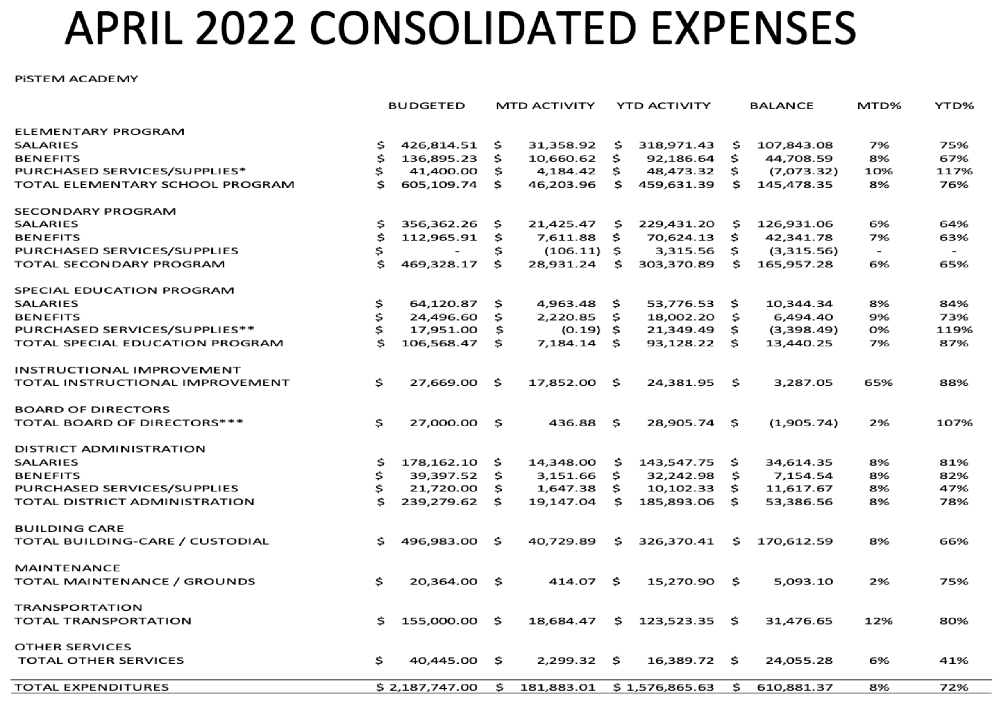
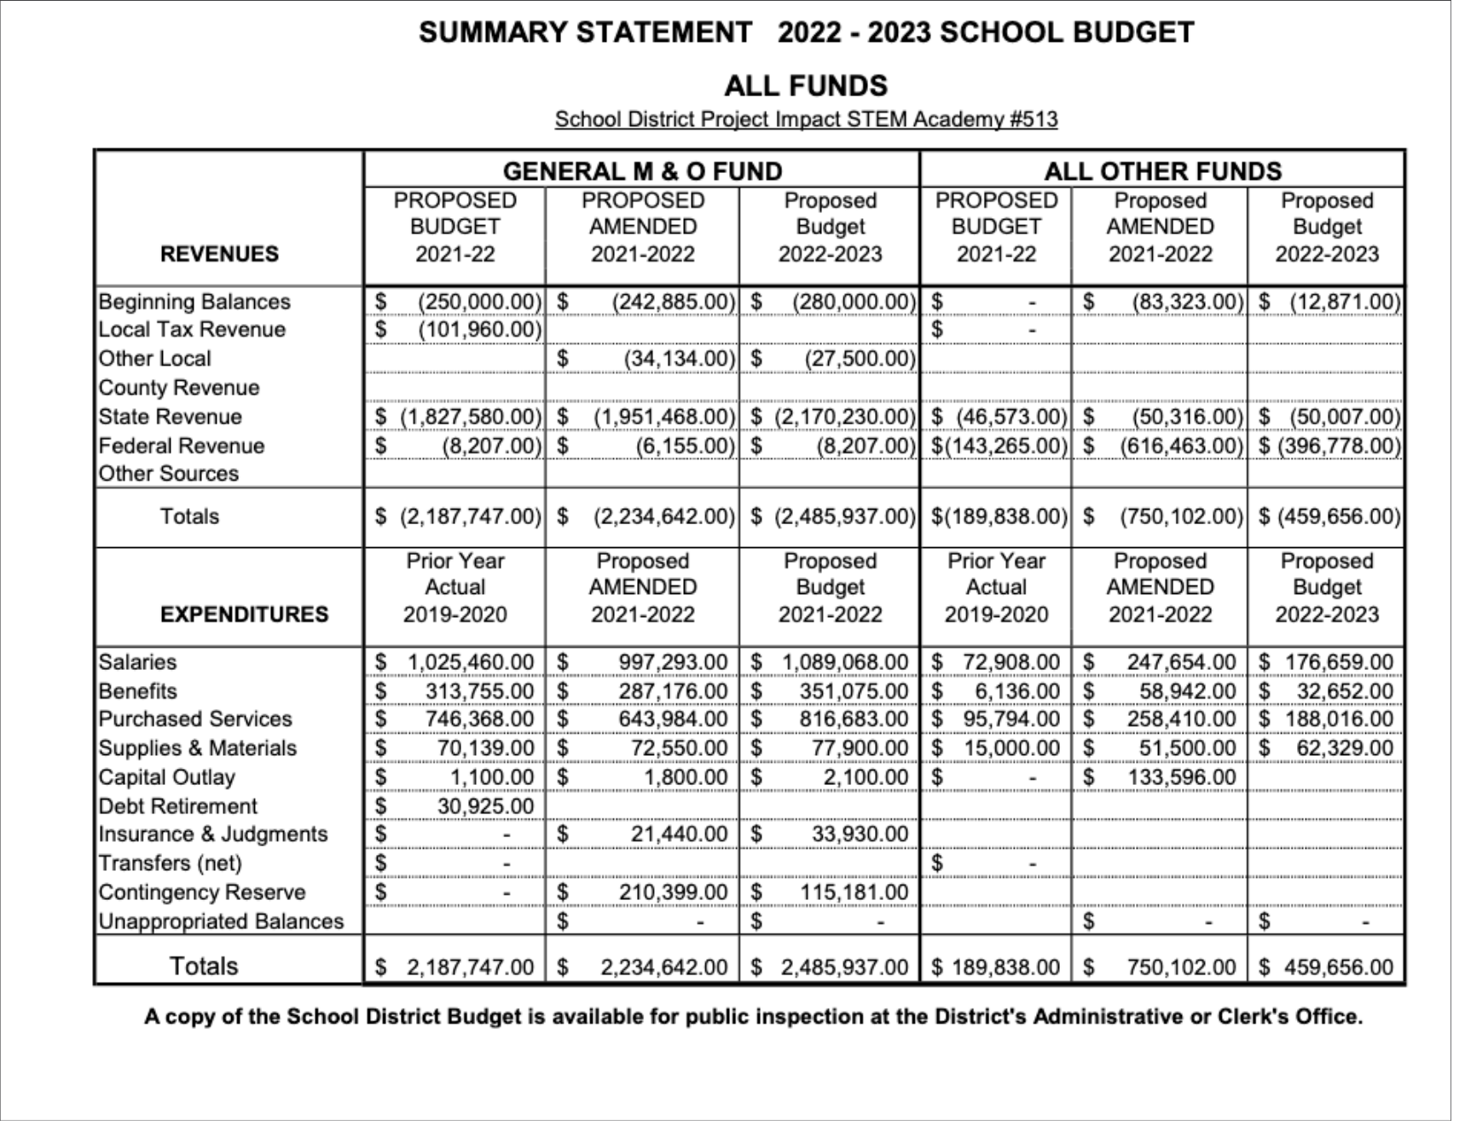
Noted SY22 Proposed Amendment Changes:

SECONDARY STUDENT ACTIVITIES Was 0, Is 1050
SALARIES- EXCEPTIONAL CHILD Was 47918, Is 44700
PERSI- EXCEPTIONAL CHILD Was 7661, Is 7277
FICA/MED EXCEPTIONAL CHILD Was 4909, Is 4663
SUPPLIES- EXCEPTIONAL CHILD Was 1000, Is 4740
MEDICAID MATCH MAINTENANCE OF EFFORT Was 3269, Is 2803
LEADERSHIP PREMIUM Was 14669, Is 19600
TRANSPORTATION-CONTRACTED Was 91000, Is 171000
RESERVE FOR DEFICIT Was 203090, Is 119774
REVENUE – TECHNOLOGY Was 41951, Is 42938
PURCHASED SERVICES – TECHNOLOGY Was 16374, Is 17361
SALARIES TITLE I Was 39533, Is 38257
BENEFITS TITLE I Was 0, Is 1276

Noted SY23 Proposed Budget Changes:

BEGINNING BALANCE Was 280000, Is 230000
ERATE FUNDING Was 0, Is 7828
ADMINISTRATOR SALARY Was 104523, Is 93714
ADMIN SUPPORT Was 102709, Is 101309
ADMIN/ADMIN SUPPORT PERSI Was 25593, Is 23484
ADMIN – FICA Was 16849, Is 15497
WORKERS COMPENSATION Was 9750, Is 10575
PROPERTY/LIABILITY INSURANCE Was 12000, Is 12860

